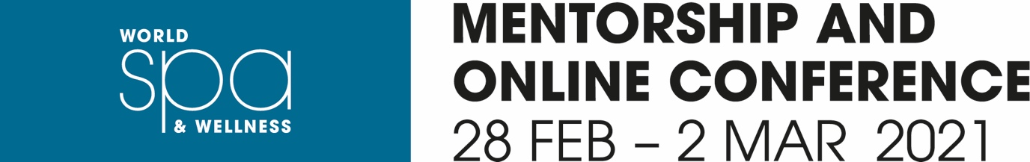

Name:

Job Title:

Name of Spa/ Hotel:

Email:

Phone Number (country code):

Please answer the following questions:

Question 1:

Which panel do you feel you have the strongest inputs to contribute to? (Please select one)

* Caring for Care-givers: best practices to take care of your teams, support them, inspire them, empower them, train them, elevate them

* Getting Guests Back, safely and gladly: menu engineering, successful new modalities, programs, membership packages, special events

* Driving engagement from online to onsite: efficient social media campaigns, engaging challenges, exciting promotions

Question 2:

Explain why you have chosen this topic. Please share with us 1 or 2 examples where you have gone above and beyond in this area of expertise. (Please use as much space as needed for your answer)

Question 3:

Which category do you feel strongly about joining? (Please select one)
* Hotel Spa
* Resort Spa
* Day Spa

Question 4:

Is the answer selected in Q3 the type of business you are working in at present?

Question 5:

What was the toughest challenge your Spa had to face in 2020 and how have you risen from the situation? (Please use as much space as needed for your answer)

Question 6:

How are you preparing yourself and your team to cope and thrive in 2021? (Please use as much space as needed for your answer)

Please send your answers as well as attach your CV or LinkedIn page to Meghna Patel at info@professionalbeauty.co.uk by 18 January 2021 where we will be able to review your application for our mini mentorship

Important information:

You will need to ensure that you are available in February, as part of your mini mentorship you will take part in the following:
- Private one-to-one session with your mentor (February)
- Group discussion with your taskforce, led by your mentor (February)
- Live discussion at the online conference on 28 February – 2 March

